Prerequisites

Learning C# basics

Before starting anything with modding for Unity Mod Manager, you should know **everything is C#.** If you don't have at least basic programming knowledge, it might be pretty hard to get your hands on it (but not impossible with motivation).  
  
What is C# ? Quoting Microsoft :

C# (pronounced "See Sharp") is a modern, object-oriented, and type-safe programming language. C# enables developers to build many types of secure and robust applications that run in .NET. C# has its roots in the C family of languages and will be immediately familiar to C, C++, Java, and JavaScript programmers. This tour provides an overview of the major components of the language in C# 8 and earlier. If you want to explore the language through interactive examples, try the introduction to C# tutorials.

[https://docs.microsoft.com/en-us/dotnet/csharp/tour-of-csharp/](https://steamcommunity.com/linkfilter/?url=https://docs.microsoft.com/en-us/dotnet/csharp/tour-of-csharp/)  
  
That being said, decide if you want to go on or not :)

Understanding or learning unity basics

I was a complete n00b with Unity when I started my first mod, and to be honest, I most probably still am. I found it to be the hardest part, because Unity has its own logic and principles, which are necessary to understand before starting.  
  
[https://docs.unity3d.com/Manual/UnityManual.html](https://steamcommunity.com/linkfilter/?url=https://docs.unity3d.com/Manual/UnityManual.html)  
  
It's even harder when modding because you won't have the Unity IDE to help you, so it will mostly be try/log/die/retry.

Having a project

Before starting, you should obviously have deep knowledge of how the game, here Stranded Deep, works, and have played a lot to know the different menus, game modes, mechanics, content, etc...  
  
Secondly, you should start with a project. Any project, even very simple, will do, but it's best (if not mandatory) to have decided *before* starting what you **want** to do.

Getting everything ready

Install Stranded Deep

It might seem obvious, but you can't mod a game you can't launch. I write it here just to be clear about it :)

Download dnSpy

Download the latest version of dnSpy here. I chose the portable version because it suits me best. I'll explain later how to use it.  
  
[https://github.com/dnSpy/dnSpy](https://steamcommunity.com/linkfilter/?url=https://github.com/dnSpy/dnSpy)  
  
For the curious :  
[https://www.systanddeploy.com/2019/08/explore-exe-or-dll-with-dnspy.html](https://steamcommunity.com/linkfilter/?url=https://www.systanddeploy.com/2019/08/explore-exe-or-dll-with-dnspy.html)

Download Visual Studio Community Edition

[https://visualstudio.microsoft.com/fr/vs/community/](https://steamcommunity.com/linkfilter/?url=https://visualstudio.microsoft.com/fr/vs/community/)  
  
You'll need VS to compile your mod. Visual Studio is, in my opinion, one of the best IDEs out there, so give it a shot, plus it's free.  
  
It can be used to build any program for Microsoft .Net.

Download Unity Mod Manager

Unity Mod Manager is the patcher that will inject your mod into the game at runtime. It patches Stranded Deep to hook your mods into the main program. It's pretty genious, and I genuinely admire the guy who made this awesome tool.  
  
[https://www.nexusmods.com/site/mods/21/](https://steamcommunity.com/linkfilter/?url=https://www.nexusmods.com/site/mods/21/)

Install UMM into Stranded Deep

Choose the "Assembly" way, it will be needed later.

Preparing your VS Solution

I'll detail the same steps as explained in this tutorial, which I followed to begin with :  
[https://wiki.nexusmods.com/index.php/How_to_create_mod_for_unity_game](https://steamcommunity.com/linkfilter/?url=https://wiki.nexusmods.com/index.php/How_to_create_mod_for_unity_game)

Creating the solution

A "Solution" when speaking .net development, is the root of one (or multiple) projects. It's the file that Visual Studio opens when you work with it. It does not really hold any intelligence, but is more a container for the .net projects.  
  
Our mod will be a .net project, so we need a solution.  
  
So, when starting Visual Studio, got to : File / New / Project, and choose :  
Visual C# / Windows Desktop / Class Library [(.Net](https://steamcommunity.com/linkfilter/?url=http://(.Net) Framework)  
  
Give it a nice name, and choose the directory in which you want to store the solution.  
  
[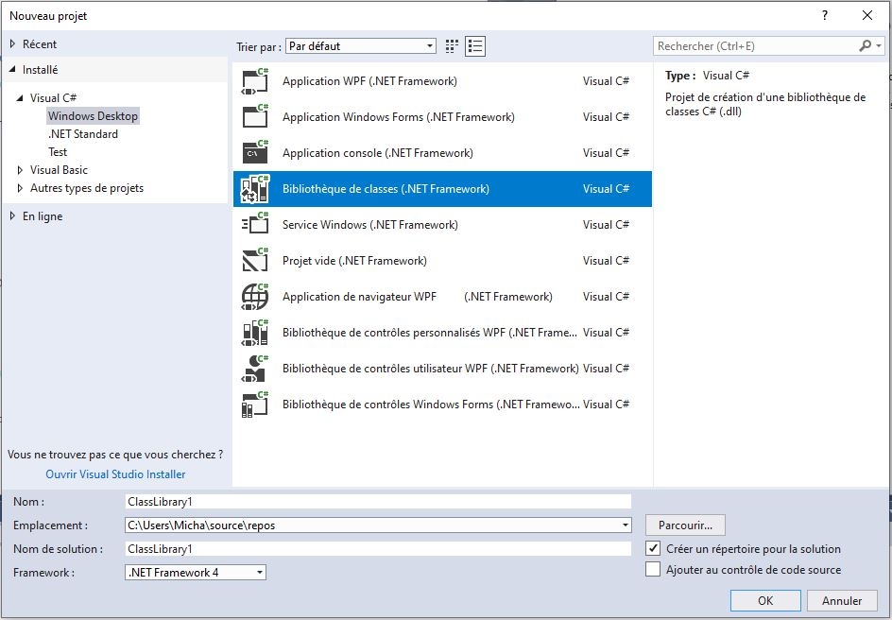](https://steamuserimages-a.akamaihd.net/ugc/1631983171020486011/C5DBE04BFF06D529ED0A5389C5BC703827047185/)  
  
**Let's call the project "StrandedDeepTutorialMod"**  
  
After that, you'll be set up with a project, but some tweaking will be needed.

Adding the right references

A "reference", when speaking .net is an assembly (DLL) which contains additional code that is used by your project.  
  
To make a working mod, we have to add the assemblies from Stranded Deep, plus the assemblies making Unity work, and finally, the UMM injector.  
  
On the right side of the screen, extend the tree of your project. You should see a node called "References".  
  
Right click on "References", and click on "Add". This opens, the reference adding menu.  
  
* Navigate to the folder where you installed/unzipped UMM, and add these references :

0Harmony.dll UnityModManager.dll

* Navigate to your Stranded Deep directory, and reference these two assemblies :

Assembly-CSharp.dll Assembly-CSharp-firstpass.dll

You'll find them in the **<...>/StrandedDeep/Stranded_Deep_Data/Managed** folder  
  
* Now we need the basic Unity references  
  
This part is a bit tricky, because it might depend on which parts of Unity you want to use. I recommend to add :

UnityEngine.dll UnityEngine.CoreModule.dll UnityEngine.UI.dll UnityEngine.IMGUIModule.dll

This should give you access to the basics.  
  
**I would recommend deleting the reference called "Microsoft.Csharp" since it is not supported by UMM, that will avoid using syntax which won't work.**

Creating the minimal files

* Delete the file called "Class.cs", we won't need it.  
  
* Then right click on the name of your project, and choose "Add / New Element"  
  
Go to : "Visual C# elements / General / Text File"  
  
Call that file "Info.json"  
  
This file will hold your mod informations.  
  
* Then repeat the "Add / New Element " and go to : "Visual C# elements / Code / Class"  
  
Call that class "Main.cs"

Preparing the Info.json file

**Id** is the name used bu UMM, it will be the name of the target directory  
**AssemblyName** must be the name of the assembly (DLL) generated by your project (e.g. StrandedDeepTutorialMod.dll).  
**EntryMethod** will describe the entry point of your mod. We have not prepared it yet, but you can use the example below to write it with this template : *AssemblyName.ClassName.MethodName*

{ "Id": "StrandedDeepTutorialMod", "DisplayName": "Stranded Deep Tutorial Mod Display Name", "Author": "YourName", "Version": "0.0.1", "AssemblyName": "StrandedDeepTutorialMod.dll", "EntryMethod": "StrandedDeepTutorialMod.Main.Load" }

Preparing the Main method

Open the "Main.cs" file  
  
Copy and paste this code into the file :

using System; using System.Collections.Generic; using System.Linq; using System.Text; using UnityEngine; using UnityModManagerNet; namespace StrandedDeepTutorialMod { static class Main { static bool Load(UnityModManager.ModEntry modEntry) { modEntry.OnUpdate = OnUpdate; modEntry.OnGUI = OnGUI; modEntry.OnHideGUI = OnHideGUI; Debug.Log("Stranded Deep Tutorial mod properly loaded"); return true; } static void OnGUI(UnityModManager.ModEntry modEntry) { } static void OnHideGUI(UnityModManager.ModEntry modEntry) { } static void OnUpdate(UnityModManager.ModEntry modEntry, float dt) { } } }

Final tweaks

* Change the properties for the "Info.json" file. Click on it, and right below, change the value :

"Copy to target directory" to value "Always copy"

* Compile your project with menu "Build / Rebuild Solution" (or CTL+SHIFT+B shortcut)  
  
If you have compilation errors, you might have missed a step above, re check everything.

Installing the mod

These steps will install the mod into Stranded Deep, and you'll see the first results.  
  
* Go to the target directory like this :  
Right click on your project, and choose "Open in file explorer"  
  
Navigate to bin / Debug  
  
You'll see a lot of files there, don't be afraid, just **select "StrandedDeepTutorialMod.dll" and "Info.json"**  
  
Right click and choose "Send to" -> "Compressed folder", rename it if you like. You should have a zip file containing your assembly, and the Info.json, like this :

StrandedDeepTutorialMod.zip

* Launch UMM, and drop this Zip file into the "Mods" tab

Drop zip files here

UMM should say Status = OK if everything went fine, if not, double check the previous steps.

Test your mod

Launch Stranded Deep, you should see the UMM interface at startup, like this :  
  
[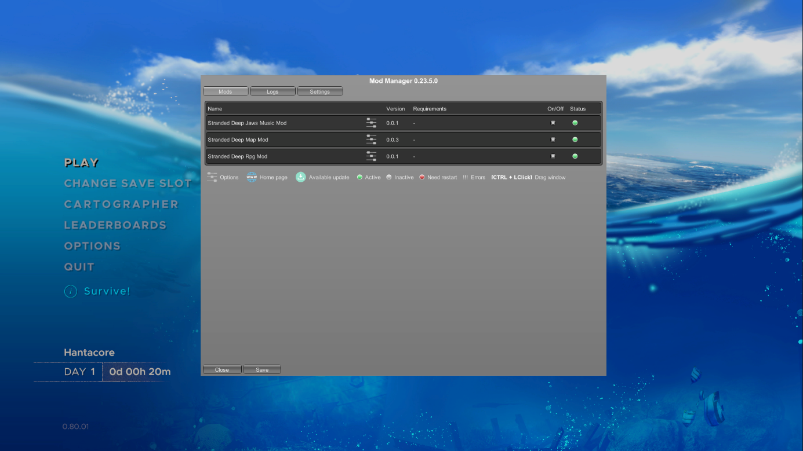](https://steamuserimages-a.akamaihd.net/ugc/1631983171020696844/598F61989246426E2A0FF6C6978D6486B5316534/)  
  
You should see your mod in the list, with a green bullet on the right under Status (saying everything was fine at Load and that the "Load" method returned "true")  
  
Now open your Data directory :

C:\Users\<user>\AppData\LocalLow\Beam Team Games\Stranded Deep\Player.log

And you should see the line inside the file :

Stranded Deep Tutorial mod properly loaded

Ultimate pro-tip

To make your mod development easier, here's a tip I use.  
  
Visual studio allows you to execute commands after building your projects. We'll use this to auto-copy the updated mod automatically into Stranded Deep without going through the whole UMM hassle.  
  
Right click on your mod project, and choose "Properties".  
  
Open "Build events", and modify the Post-Build event

copy /Y "$(TargetDir)Info.json" "<PATH TO STRANDED DEEP>\Mods\StrandedDeepTutorialMod\." copy /Y "$(TargetDir)StrandedDeepTutorialMod.dll" "<PATH TO STRANDED DEEP>\Mods\StrandedDeepTutorialMod."

Don't forget to change <PATH TO STRANDED DEEP> to the right folder holding Stranded Deep.  
  
Try and rebuild your project, if everything went fine, you should see no error.  
  
If you get a copy error, you may have mistyped the commands for your post-build event, check the assembly name and the target path (it should exist)

That's it for now

Now you have all the bases to start working on your mod !  
  
We'll get into more serious things.

First steps

How does it work

Unity, like every game framework, is **sequential programming**  
  
UMM gives access to some steps of the lifecycle of the game.

Load = is called at the loading of the mod, and only once OnGUI = is called every time the UMM GUI is opened (with CTRL+F10, or at start) OnHideGUI = is called every time the UMM GUI is closed OnUpdate = is called at every game frame

What does it mean ? It means that every frame (yes **EVERY FRAME**) calls the "OnUpdate" method.  
  
Keep that in mind when coding your mod, because if you do heavy calculations in the "OnUpdate" method, it will drastically drop your framerate (FPS)  
  
You have a complete reference of the events you can catch on this page  
[https://wiki.nexusmods.com/index.php/How_to_create_mod_for_unity_game](https://steamcommunity.com/linkfilter/?url=https://wiki.nexusmods.com/index.php/How_to_create_mod_for_unity_game)

Handle exceptions

When coding your mod, alway assume something will go wrong.  
  
Be very careful with your exception handling.  
  
[https://www.tutorialspoint.com/csharp/csharp_exception_handling.htm](https://steamcommunity.com/linkfilter/?url=https://www.tutorialspoint.com/csharp/csharp_exception_handling.htm)

Handling UMM GUI

You may want to use the GUI to simply change some game values, this happens in the OnGUI method, somehow like this :

static void OnGUI(UnityModManager.ModEntry modEntry) { GUILayout.Label("God mode"); health = GUILayout.TextField(health, GUILayout.Width(100f)); ammo = GUILayout.TextField(ammo, GUILayout.Width(100f)); if (GUILayout.Button("Apply") && int.TryParse(health, out var h) && int.TryParse(ammo, out var a)) { Player.health = h; Player.weapon.ammo = a; } }

This code will most probably not work, and is given as a pure example

Catching key press

One of the first things i wanted to do was reading the user input. To achieve this, you will have to read the Unity Events inside the OnUpdate loop, like this :

static void OnUpdate(UnityModManager.ModEntry modEntry, float dt) { try { Event currentevent = Event.current; if (currentevent.isKey) { if (currentevent.keyCode == KeyCode.F8) { // do something } if (currentevent.keyCode == KeyCode.F9) { // do something else } } } catch (Exception e) { Debug.Log(e); } }

OK, thats nice, but how do I know what to do with the Stranded Deep code ?

That's the tricky part.  
  
Open **DnSpy** which you should have downloaded earlier.  
  
DnSpy is a **decompiler** which will give you access to the game code.  
  
BUT, it's unity code, so it's not so easy to understand, as you will not have access to the insides of Unity itself. You'll have to guess how things work by reading the code.  
  
[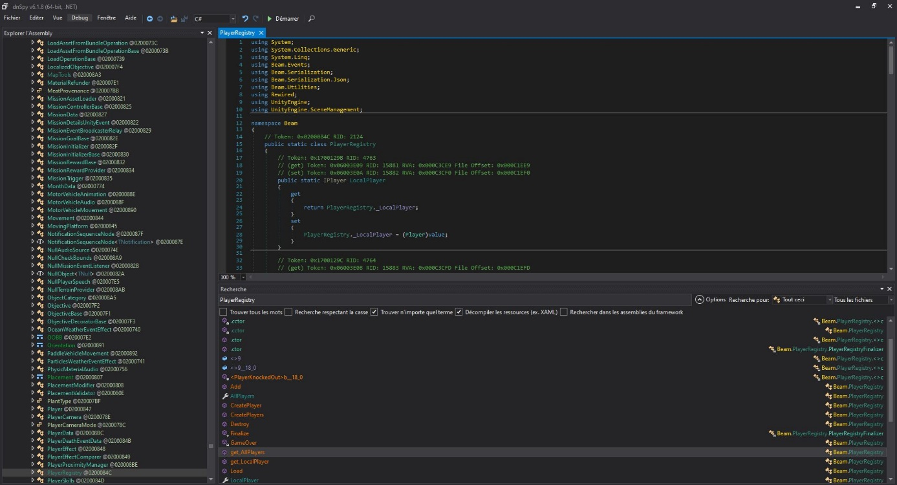](https://steamuserimages-a.akamaihd.net/ugc/1631983171020776695/653A31304CF0084914965C48EEB9C5B248FFB153/)  
  
Here's how it looks to dig into the player information : I found out that they are stored in the PlayerRegistry, and kept digging. This is why having C# knowledge becomes mandatory if you wish to do some advanced stuff with your mod.  
  
Here's what i've learned so far :

Beam.GameState = get the game state Beam.PlayerRegistry.AllPlayers = access player information Beam.Crafting.CraftingCombination = access crafting combinations Beam.Terrain.World.MapList = access the world as it is loaded from the .MAP files StrandedWorld.Instance.Zones = access the world as it is loaded in the game memory Singleton<LE_LevelEditorMain>.Instance = the island editor content SoundtrackManager.Instance = handles the music in the game

And quite a lot more, but I'll let you find out what you need yourself, do not hesitate to contact me if needed.

.net Reflection to access hidden properties

Sometimes you will need to access properties that are voluntarily not made public, it's a pretty common way of doing things in development. Still, you might need to access them while creating mods.  
  
This is still possible in .net using something called "Reflection". It's extremely powerfull, but be aware that it might be performance consuming. Use it wisely.  
  
[https://stackify.com/what-is-c-reflection/](https://steamcommunity.com/linkfilter/?url=https://stackify.com/what-is-c-reflection/)  
  
Here's an example I used in one of my mods to access a specific hidden object inside the StrandedWorld instance :

ZoneLoader loader = typeof(StrandedWorld).GetField("_zoneLoader", BindingFlags.NonPublic | BindingFlags.Instance).GetValue(StrandedWorld.Instance) as ZoneLoader; if (loader != null) { loader.LoadedZone -= Loader_LoadedZone; loader.LoadedZone += Loader_LoadedZone; }

More advanced stuff

Work in progress

Loading images without modifying game assets

To use new textures without changing the assets of the game, we need to bypass the way Unity loads its assets, and hack the textures into the renderers. Here's how I did it (and it is very possible there are easier or better ways).  
  
First, add the textures to the project.  
These textures need to be configured as "Embedded resources" (right click on the texture, then Properties -> Generation action = Embedded resource)  
  
The magic is then to be able to load these images as textures for unity, namely "Texture2D".  
  
First step is to read the resource as a byte array, here's an example method that I use :

public static byte[] ExtractResource(String filename) { System.Reflection.Assembly a = System.Reflection.Assembly.GetExecutingAssembly(); using (System.IO.Stream resFilestream = a.GetManifestResourceStream(filename)) { if (resFilestream == null) return null; byte[] ba = new byte[resFilestream.Length]; resFilestream.Read(ba, 0, ba.Length); return ba; } }

Then I load the byte array into a Texture2D object for Unity (be aware that the texture size must match the size of the image. For now I mainly tested this with PNGs, but it should work with JPGs.

// 4096 is the size of the image Texture2D tex = new Texture2D(4096, 4096, TextureFormat.ARGB32, false, false); // call the LoadImage method to read the image into the texture tex.LoadImage(ExtractResource("path/to/ressource.png"));

Now that you have a Texture2D object, you can do almost what you want with it, display it on screen in a canvas, or use it in a Material for 3D rendering.  
  
[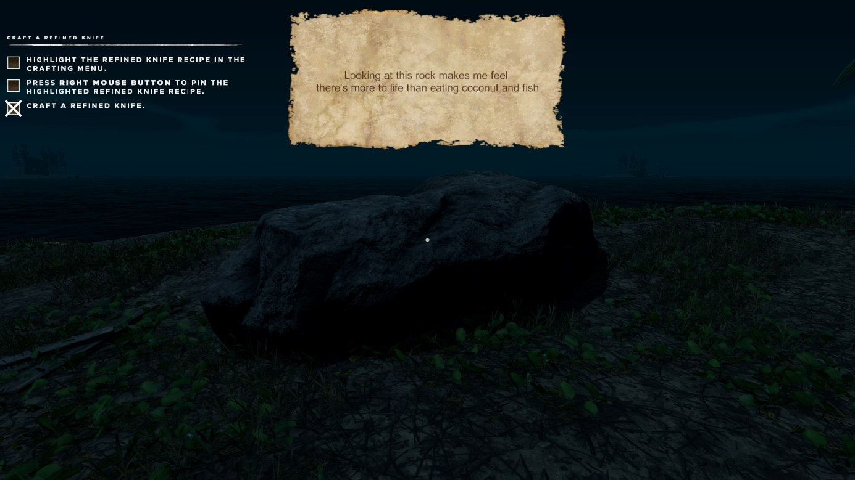](https://steamuserimages-a.akamaihd.net/ugc/1844802808240476958/10666DBFC548A88754F50A1BE2583BC6B53293E8/)  
[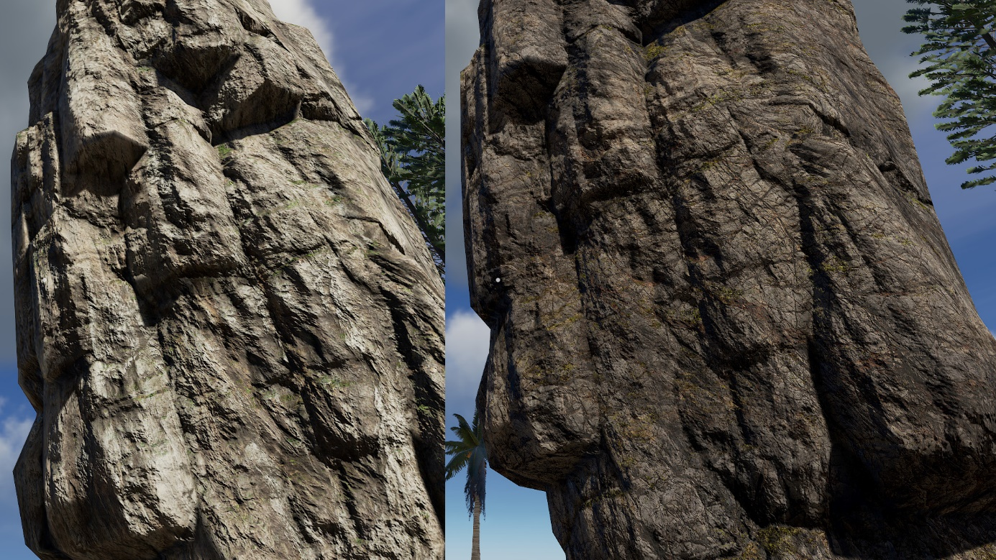](https://steamuserimages-a.akamaihd.net/ugc/1844802808240478624/DFF0B2FF5DD5A3631179719A96F0D78D17D90E2E/)

Loading sounds without modifying game assets

This one is a bit more tricky. Here is how I did it.  
  
Unity re-encodes the sound assets before shipping, this is why we are constrained to specific formats when injecting sounds into a mod.  
  
What I wanted to do was to read a file on a drive, and play it into the game.  
  
The first trick is to be able to read the sound/music as a Unity AudioClip. For this task, I used a very nice utility, called WavUtility :  
[https://github.com/deadlyfingers/UnityWav](https://steamcommunity.com/linkfilter/?url=https://github.com/deadlyfingers/UnityWav)  
  
Then either you can read the file as a byte array from disk, or from the resources (same way of embedding and reading as images, see previous section).

AudioClip clip = WavUtility.ToAudioClip(ExtractResource("path/to/resource.wav"));

The caveeat is that I had to convert the audio to a specific format :  
44100Hz sampling, 16bits sample size

Adding image layers to the game

WIP  
  
[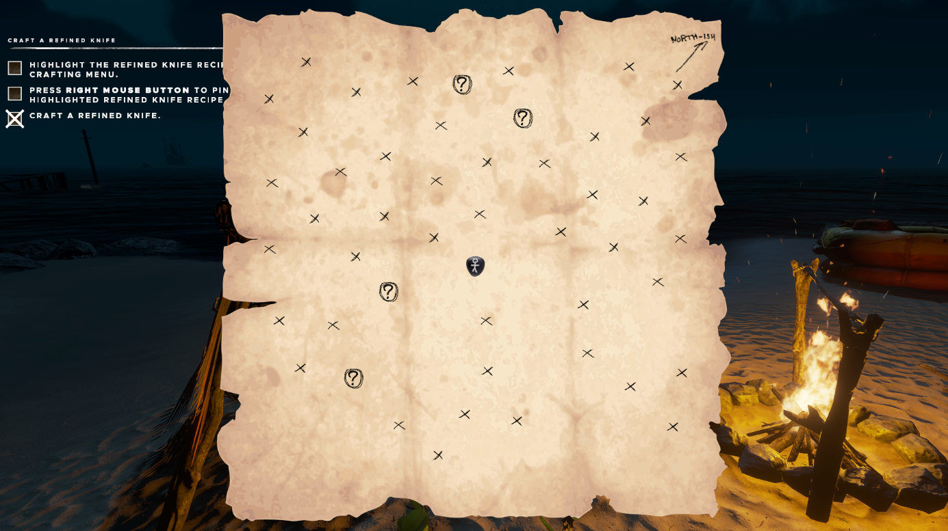](https://steamuserimages-a.akamaihd.net/ugc/1844802808240486207/81002887D347BC783538244562C7F4875817FC4B/)

Storing your mod configuration

To retain the user settings whenever you want to, you have to write it down on disk. UMM ships (if I remember correctly) with a configuration management, but I wanted to write my own for more flexibility.  
  
I wrote two methods : WriteConfig, ReadConfig which handle a file written in a simili-INI format.

private static string configFileName = "StrandedDeepTutorialMod.config"; private static bool myConfigValue = false; private static void WriteConfig() { string dataDirectory = System.IO.Path.Combine(Environment.GetFolderPath(Environment.SpecialFolder.LocalApplicationData).Replace("Local", "LocalLow"), @"Beam Team Games\Stranded Deep\Data\"); if (System.IO.Directory.Exists(dataDirectory)) { string configFilePath = System.IO.Path.Combine(dataDirectory, configFileName); StringBuilder sb = new StringBuilder(); sb.AppendLine("configValue=" + myConfigValue + ";"); System.IO.File.WriteAllText(configFilePath, sb.ToString(), Encoding.UTF8); } } private static void ReadConfig() { string dataDirectory = System.IO.Path.Combine(Environment.GetFolderPath(Environment.SpecialFolder.LocalApplicationData).Replace("Local", "LocalLow"), @"Beam Team Games\Stranded Deep\Data\"); if (System.IO.Directory.Exists(dataDirectory)) { string configFilePath = System.IO.Path.Combine(dataDirectory, configFileName); if (System.IO.File.Exists(configFilePath)) { string[] config = System.IO.File.ReadAllLines(configFilePath); foreach (string line in config) { string[] tokens = line.Split(new string[] { "=", ";" }, StringSplitOptions.RemoveEmptyEntries); if (tokens.Length == 2) { if (tokens[0].Contains("configValue")) { // parse corretly here according to target type myConfigValue = bool.Parse(tokens[1]); } } } } } }

Tips and tricks specific to Stranded Deep

Game states

public enum GameState { MAIN_MENU, INTRO, NEW_GAME, LOAD_GAME, MAP_EDITOR }

* MAIN_MENU : when you are in the main menu, which means every UI outside the 3D game itself
* INTRO : during the intro in the crashing plane
* NEW_GAME : inside a game that has never been saved / loaded
* LOAD_GAME : when you play a loaded game
* MAP_EDITOR : inside the cartographer 3D UI

Available shaders

(WIP)

* **Standard** = (has bump)
* **Standard (Extra)** = (has bump)
* **Standard (Two Sided)** = (has bump)
* **Beam Team/Standard/Skin/Skin** = (no bump)
* **Standard (Specular setup)** = (has bump)
* **Hidden/Amplify Impostors/Octahedron Impostor** = (has nothing)
* **Beam Team/Standard/Particles/Additive** - Night Fade = (no bump)
* **Beam Team/Particles/Alpha Blended** = (no bump)
* **Beam Team/Stipple Billboard CG** = (no bump)

Material mat = new Material(Shader.Find("Standard (Specular setup)"));

Accessing the players information

IList<Beam.IPlayer> players = Beam.PlayerRegistry.AllPlayers; for (int playerIndex = 0; playerIndex < players.Count; playerIndex++) { Vector3 playerPosition = players[playerIndex].transform.localPosition; // whatever }

Accessing the islands information

Beam.Terrain.Map[] maps = Beam.Terrain.World.MapList; for (int islandIndex = 0; islandIndex < maps.Length; islandIndex++) { if (StrandedWorld.Instance.Zones.Length > islandIndex) { bool discovered = StrandedWorld.Instance.Zones[islandIndex].HasVisited || StrandedWorld.Instance.Zones[islandIndex].IsStartingIsland || debugMode; } }

Savegame structure